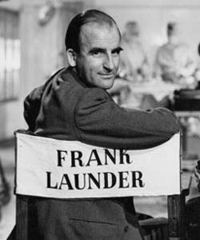
C. George Sandulescu, Editor

Film Director
Frank Launder’s

Last Interview
given on Thursday
11 May 1989 in Monaco

ISBN: 978-606-8366-31-9

© C. George Sandulescu

Technical editor: Professor Lidia Vianu

Transcription: Angelica Ţăpoca
IT Expertise: Simona Sămulescu
Publicity: Ruxandra Câmpeanu.

C. George Sandulescu, Editor

Film Director
Frank Launder’s
Last
Interview
given on Thursday 11 May 1989 in Monaco

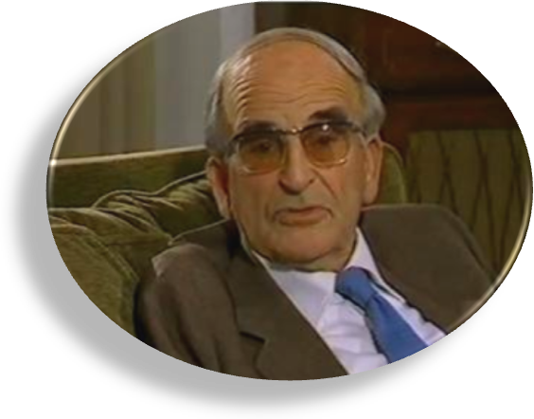

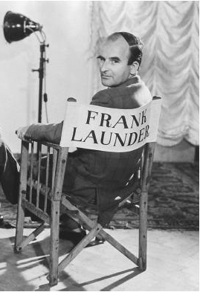

Table of Contents

C. George Sandulescu: Film Director Frank Launder’s Last
Interview, given on Thursday 11 March 1989 in Monaco, p. 5
Frank Launder’s Last Interview, p. 7

Film Director Frank Launder’s Last Interview
given on Thursday 11 March 1989 in Monaco

To make a film, one must have two things the image and the script. And a third thing, too: the idea that brings them together.
In consequence, film directors fall, in my opinion, into two major categories: the image men & the script men. Frank Launder was among the first and the greatest of the latter group in Great Britain. As such, he became the most outstanding by far President of The Film Script Writers’ guild in Britain.
He had the longest career in making silent films, black-and-white films, and also colour films. He retired on the Riviera, with wife and four children, and stayed there for solid 30 years, since before the early 1970’s, until, practically, the year 2000.
In this interview, he speaks about boycott the man, the word, the film, the impact, the money, the actors, the associates...
This was, it so turned out, Frank Launder’s last public appearance, and his last interview.
I was the lucky man who organized, and put together the whole memorable event. And I must say, to wind up with, that I was introduced to him for the very first time only five minutes before the interview took place.

C. George Sandulescu

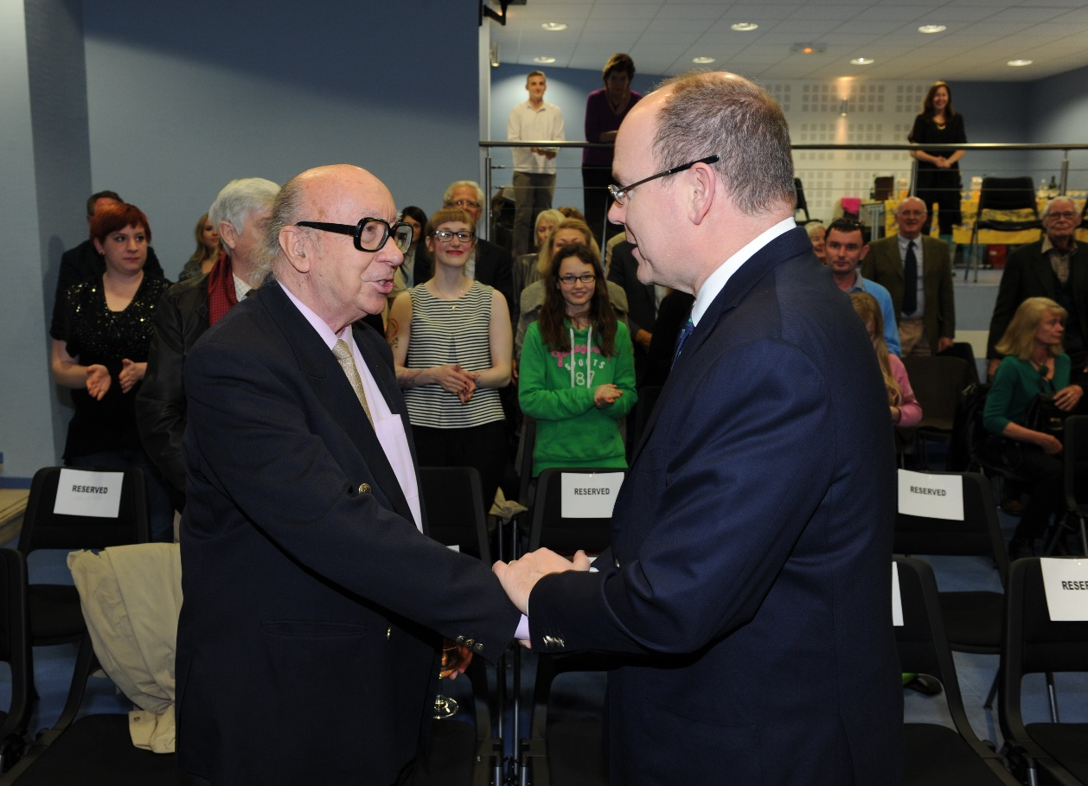
H.S.H. Prince Albert of Monaco shaking hands with George Sandulescu on Friday 30 March 2012

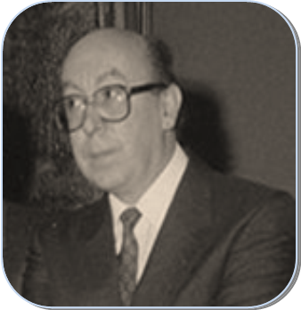
Thursday 11 May 1989
Princess Grace Library

C. George Sandulescu,
Director of Princess Grace Library:

Ladies and gentlemen, I am happy to see you again tonight. For the first time, we are not talking: we are showing a film. You all know what the film is about, and we are privileged to have the film director here with us: Mr Frank Launder.
I am not in the habit of making lengthy introductions, which I always do, but I have always been attracted by language, and always been attracted by situations of conflict. In a sense, we are in a situation of conflict: there is the conflict now in the arts between the word and the image. What is more important today? Is it the written word of literature, or is it the image of the film?
There is a lot of discussion about this, and there is the “image explosion” in the past twenty years or so. This goes back to Marshall McLuhan, who was the first to notice and say that the medium is the message. What I want to say is that there is something in the medium, which is the cinema medium, which we are presenting tonight.
But it is not only cinema. This is what I want to emphasize. There is this story, or the story behind the story, or the story behind the film. Well, let us say, the book behind the film, and the real story behind the book, created a word: the word “boycott”. And we all remember how the Americans boycotted the Moscow Olympic Games, which would be inconceivable now. How Rhodesia was boycotted, and how boycott came to be a very important word in the newspaper vocabulary, in a very strange way.
I am sticking my neck out – I have not consulted the director – that it is not only thanks to the real story, which was sometime in the 1880s, it is not only thanks to the book, which was in 1946, but it is also thanks to this film that you are going to see, that a contribution was made not only to one language, but to all languages of the world, simultaneously.
Whatever “boycott” means, you will see at the end of the film, and I hope there will be some discussions. Mr Launder was kind enough to accept to take a few questions at the end of the film.
There is a brief interview at the beginning, of two minutes, and then there is the film, and I do apologize for some advertising interludes, which we are trying to do away with, with your assistance.
I am privileged to give the floor to Mr Frank Launder to present this film. Two actors of the film are present in the room. I will not say more. Mr Launder...

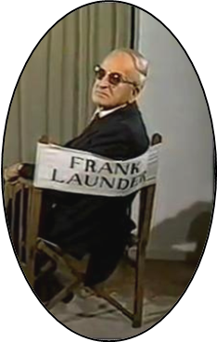

Frank Launder:

Good evening ladies and gentlemen. The film is really a page of history, rather than the story of one man, because Boycott himself was probably one of the most publicized non-entities that ever existed. Many famous names go into the English dictionary, but they are mostly nouns when you come to think of it: Napoleon is a game of cards, Wellington is a pair of boots. These are, you see, half nouns, not whole nouns...
But we have only one verb that I can think of, and that is “boycott”. And this goes in twenty-three languages as boycott, it always starts with boycott. I think that, if he were alive, if he had been at the time it happened, he would take a bow, wouldn’t he? To be in twenty-three different dictionaries.
But he was not, of course, the villain of the piece at all. He was a simple man, and perhaps a bit pompous, and a bit of a clown, too. The real villain of the piece was the Earl of Erne, who was an absentee landlord who owned half of County Mayo and a great slice of Sligo.
What amazed me was that the press did not go after him. They went after Boycott. Whereas you would have thought that, while he was down, he was living in Brighton, and all he did, he moved to Bournemouth. He moved down the coast, that’s all. Nowadays of course he would go to Costa Del Sol or Miami, wouldn’t he?
He was the man who should have been blamed for all the trouble, but he was not.
But, now, on the the film itself. When we made it, we had our own company, and we made it under the banner of the Rank Organization.
They had a funny system. Those days, going back to the time, it was very expensive to make films in colour. A lot of thought was going before we put in the colour, assuredly. They went on a rule of thumb: we had board meetings about it. They would say, well, “Red Shoes – colour”... But when it came to Boycott, we couldn’t, so we shot it in black and white.
In the film, there are three people associated with Monaco. Two of them are here tonight. One was a young medical student, whom you will see briefly, quick, pulling Boycott off his horse, in the race. Running onto the course and pulling him off, with a couple of other chaps. He ended up in hospital for a day, but he is here tonight. Then, a young actress, the first time appearing in a film. She is in the film, and I was lucky enough to marry her later on. She’s here tonight. The third one was a young lieutenant in the Irish army: he was a daring rider, and he doubled for Stewart Granger all the riding scenes. Riding uphill and down dale over the stony ground, to the mountains of Mayo, and outjumping stone fences and everyting. Well, he ended up as the head of the Bank trustee department. We constantly visited him. I would hardly have thought it a risk-taking job. He is not here today.
I had something else to say. I do not remember what it was. I will have a look. I made some notes...
Oh, just to say that we had the films taped, you see. My partner and I had a programme about films shown on Channel 4 in England – we’d take lead interviews before most of the films – and this interview came before the film. Unfortunately, my youngest daughter, who was taking it to put it onto video, was cooking at the time, and she did not switch it on right away, so you will miss a bit of the beginning. Otherwise I think that is all I need to say.

ΔΔΔΔΔΔΔΔΔΔΔ

It is at this point of the evening that the film entitled Captain Boycott is presented in full to the public.

ΛΛΛΛΛΛΛ

George Sandulescu (at the end of the film):

Please, don’t boycott a few minutes’ discussion, as we have the privilege of the director here. I think I felt I was back in the days before the plague of television was with us. For good or for bad. Mr Launder..

[Voice from the public]: Does the race bear any legitimate facts, historical facts?

Frank Launder: Yes, there was a race. It did not happen quite in that way, but...

George Sandulescu: What was the difference?

Frank Launder: Well, the difference is that they did not pull him off the horse, you know.

[Voice from the public]: Was he still considered a winner?

Frank Launder: No, he did not win.

George Sandulescu: Which was the most difficult part of the film to do? Was it this race, in particular?

Frank Launder: It was all fun. The worst part was that it rained and rained. We had to wait with the Irish army. The Irish army lent us all their gear. We were quite willing to dress up. They were stuck up on a hill there, and it poured for weeks. We were waiting for the sun to come out. Sitting in an Irish mist, you can’t hope of anything, as you can’t see anything. That is the trouble. Because, today, you can do it much more easily with colour, because you can film beautifully in bad weather, but you can’t film in black and white in bad weather, that’s the difference.

[Voice from the public]: In fact, it did rain for three weeks.

[Another gentleman from the public, James Duffy, the Monaco solicitor]: May I be so bold as to ask what the film cost?

Frank Launder: Well, it didn’t cost as much as you’d think. It cost quite a bit, but in those days... I’m trying to remember what it did cost: something around two hundred and fifty thousand, two hundred thousand.

Mr James Duffy: Of course, you know that, today, even the simplest movie costs forty million, in dollars.

Frank Launder: Well, no, not all... All that money wasted. I think our chief loss was due to rain; that cost more than anything. But I want you to consider, that race course, we paid that local town two pounds a piece, I think three, if you brought your own costume. We only put one advertisement on the cinema there, and the whole town came in. And they all managed to find some 1880 costume, they all got three pounds...
But it was the tinkers that came in, or the travelling people, as they are called. The crowds were enormous, we did not pay them. I mean we did pay, as that little piece at the beginning said. We threw them a handful of money, but a lot of that crowd was free... It looked quite an enormous crowd.
Incidentally, we chose Mullingar because that is the only grand stand, or was the only race stand in Ireland, in 1880. It was rebuilt at a later later date, but it was a good old stand. And, of course, we had all the trainers of Ireland, who brought their horses with them; we persuaded them to bring horses. We borrowed their horses. We did have an advantage, because we were working for Rank, and Rank’s brother was a big race-horse owner in Ireland, and so we persuaded him, talked to his pals to lend us the horses, so it did not cost us an awful amount of money for the horses.

[A voice from the public]: Mr Launder, were you trying to make an interesting movie, or a political statement?

Frank Launder: No, I do not like political statements. I am not a political animal. I made it because I liked the idea. It struck me as an interesting piece of history.

George Sandulescu: You were saying before this that the statements made by Parnell were verbatim statements. But what about the press cuttings from the newspapers of the time, which briefly were on the screen. They were actual press cuttings... They were the originals.

Frank Launder: Yes, we did a fair amount of research to get all that right.

[Another voice from the public]: Except that Parnell started by saying to shun not the land grabbers, but the landlords, they were the first people he said you should shun. The landlords and the agents, and, afterwards, the land grabbers.

[Voice from the public]: I do not think it was very clear that the workers, the volunteers... where they came from. They came from Northern Ireland. They were in fact Orangemen.

Frank Launder: Yes, that’s right. Of course, the troops came from Northern Ireland, too; the march was from Belfast.

George Sandulescu: Well, to wind up, the interesting idea which comes out from this film, is that the one who initiated the phenomenon of boycott was Parnell himself, who said in that piece: “Shun, avoid, excommunicate.” Which takes us back to the religious history: “boycott” is a pretext name behind an idea, which was ultimately Parnell’s. Which is not very far from Gandhi’s non-violence attitude.

[Voice from the public]: Parnell was very well cast: perfect.

Frank Launder: I tried. Actually, I tested two or three Irish actors, but I wanted someone who had some experience in acting, and Robert Donat always had that experience.

George Sandulescu: Well, in token of gratitude, on behalf of the Princess Grace Library, we would like to offer something, a token of gratitude, as I said, to Mr and Mrs Launder: for their presence, for this evening, for this show, for this discussion, for everything.

Frank Launder: Thank you!

